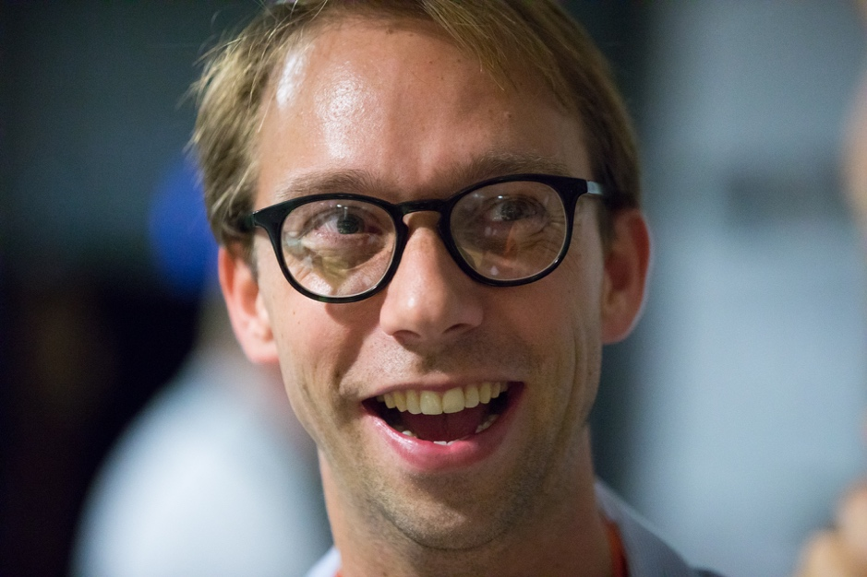

title
portable laser cutting

abstract
My research is in digital fabrication, a subfield of human-computer interaction (HCI). In my PhD work, I have been focusing on a specific fabrication technology, i.e., software systems for laser cutting. My specific objective is to create a technological basis that allows designers and engineers of laser cut 3D models to build on each other’s work, as I see this as being instrumental in allowing this nascent field to increase in model complexity and adoption—a progression that is currently held back by the use exchange formats that disregard mechanical differences between machines and therefore overlook implications with respect to how well parts mechanically fit together (aka engineering fit). In my PhD, I thus explore better ways for representing models.

I started my PhD work by preserving the 2D format currently in use, by writing software tools that replace machine-specific features (press-fit and loose-fit) with more forgiving mechanical elements, i.e., specific types of springs (full paper ACM UIST’19) and a novel type of bearing I engineered (full paper ACM UIST’20). While these allow users to reproduce 3D models across machines, the field needs access to parametric modifications in 3D to build on work of others. I created elements of a software system that allows modeling laser-cut models in 3D (volume-based construction, full paper CHI’19 and the integration with plate-based construction in submission to CHI’22). Users then export the 3D models to their specific machine, which solves the portability question. It does raise a question of what to do with the vast amount of existing 2D cutting plans. To handle this legacy, I have written a series of software tools that allow users to convert existing 2D cutting plans into 3D models, by reconstructing the 3D nature of the model using a set of interactive manual tools (full paper CHI’20), I then progressed to an automatic approach based on efficient graph algorithms (full paper UIST’21), which I will revisit yet again using computer vision to cover most models shared online.

I have integrated these tools into the above-mentioned system (kyub, 140,000 lines of code). To test each of my technologies with hundreds of models from this model repository, and by running workshops with school classes to see that my software lets users progress to more complex models such as furniture and guitars. This system integration also allows me to push forward to actual use. I believe that by simplifying sharing and re-use and the resulting increase in model complexity, this line of work and the resulting system will ultimately help personal fabrication scale past the maker phenomenon it currently is and towards a mainstream phenomenon—the same way that other fields, such as print (postscript) and ultimately computing itself (portable programming languages, etc.) to reach mass adoption.

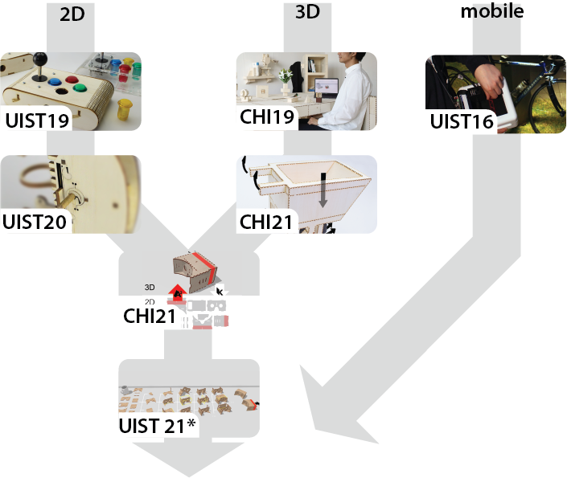

biography
Thijs Roumen is a PhD candidate in Human Computer Interaction in the lab of Patrick Baudisch, Hasso Plattner Institute in Potsdam, Germany. He received his MSc from the University of Southern Denmark, Sønderborg in 2013 and BSc from the Technical University of Eindhoven, Netherlands in 2011. Between the PhD and master he worked at the National University of Singapore as a Research Assistant with Shengdong Zhao. His research interests are in personal fabrication, digital collaboration and enabling increased complexity for laser cutting. His papers are published as full papers in top-tier ACM conferences CHI and UIST. He serves on several ACM program committees including ACM UIST and CSCW.

